AWS IAM
User & User Group Creation
Objectives:-
- Facilitate permission assignment to groups rather than individual users, reducing administrative overhead.
- Ensure scalability and consistency in large teams by updating group policies that propagate instantly.
- Promote security best practices like least privilege, avoiding direct user-level permissions where possible
- Part 1 A : Creating the first IAM Users
- We create 2 IAM users with console access and add the AmazonS3FullAccess policy to each user.

- Step 1 : IAM Dashboard
- The IAM Dashboard is the main interface for managing access and security in AWS. It allows users to create and manage IAM users, roles, and permissions.
- From this dashboard, you can view security status, apply policies, and control who has access to AWS resources. It also provides important recommendations like enabling MFA for better account protection

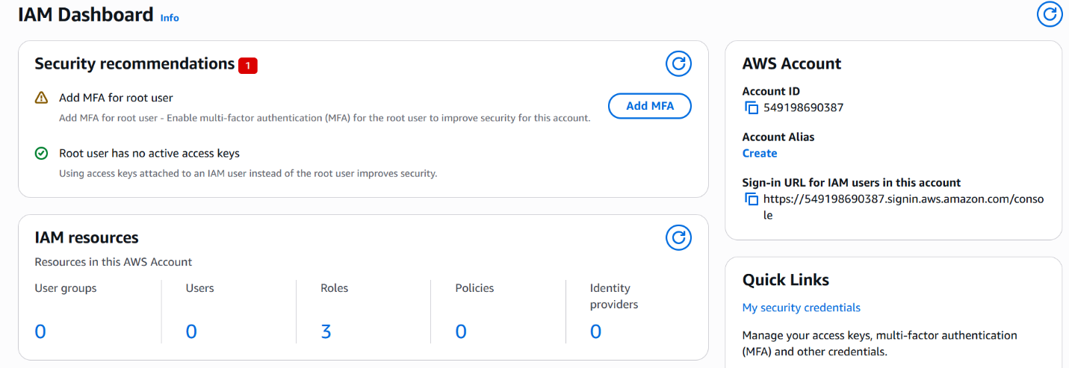

Step 2 : Creating a User
This step involves creating a new IAM user to provide access to AWS resources. A unique username is assigned, and the type of access (programmatic or console) is selected. It ensures that individuals can securely access the AWS account with specific credentials instead of using the root account.

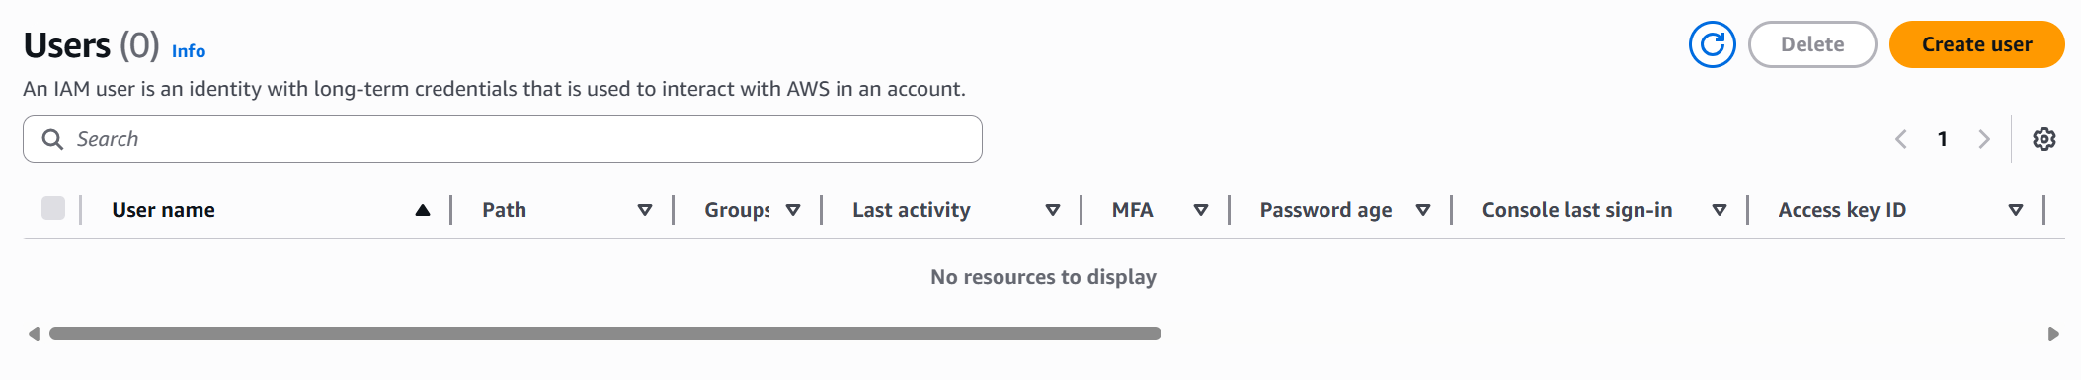

UserName: anup
Enable: Provide user access to the AWS Management Console
Password: Anup123@

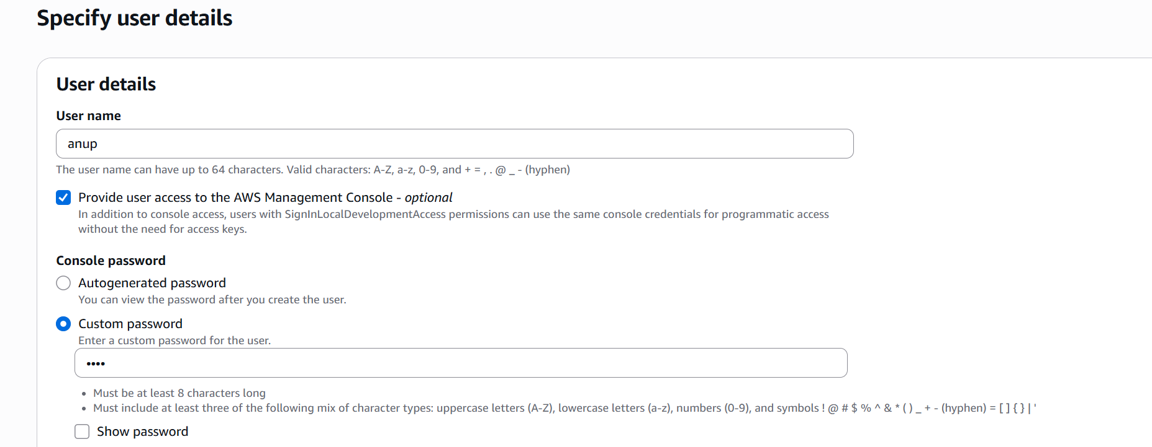

Step 3 — Set Permissions
On the Set permissions page, choose how to assign permissions to this user.
Select: Attach policies directly
• In the search bar, type: s3
• From the results, check: AmazonS3FullAccess
• Click Next to proceed to the review page
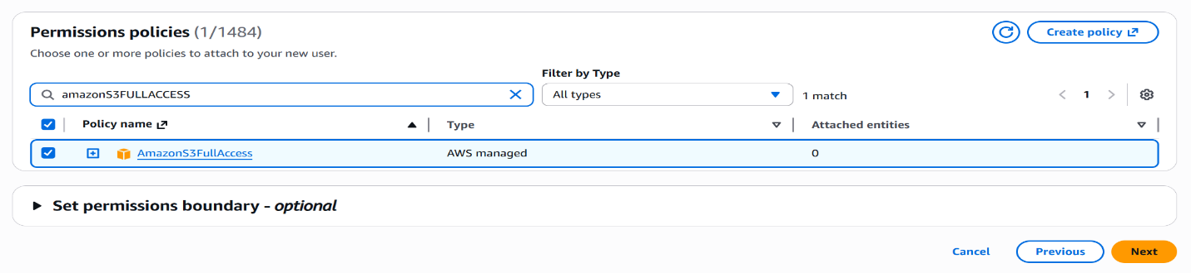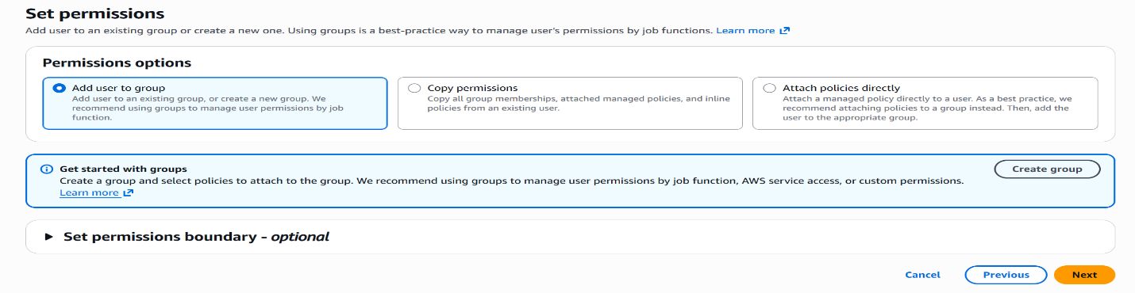

Step 4 — Review and Create
The Review and create page shows a full summary before the user is created. Click Create User.

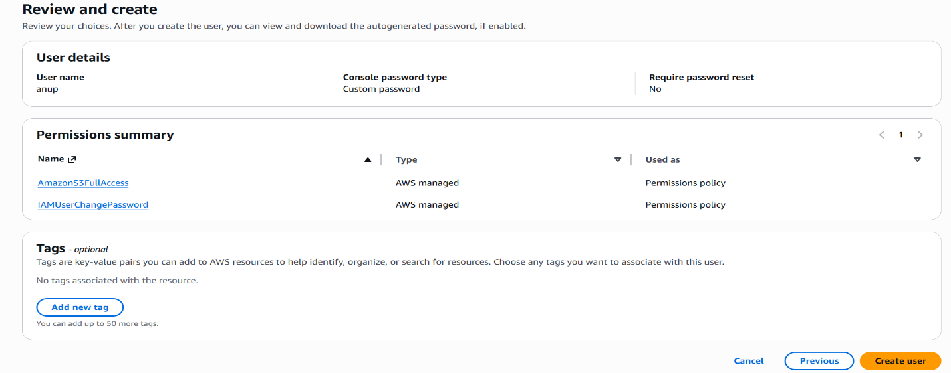

Step 5 — Retrieve Password and Confirm Creation
After clicking Create user, you will see a success banner: "User created successfully". The console then shows the sign-in credentials.
Save the details— the password will not be shown again:
• Console sign-in URL
• User name
• Console password
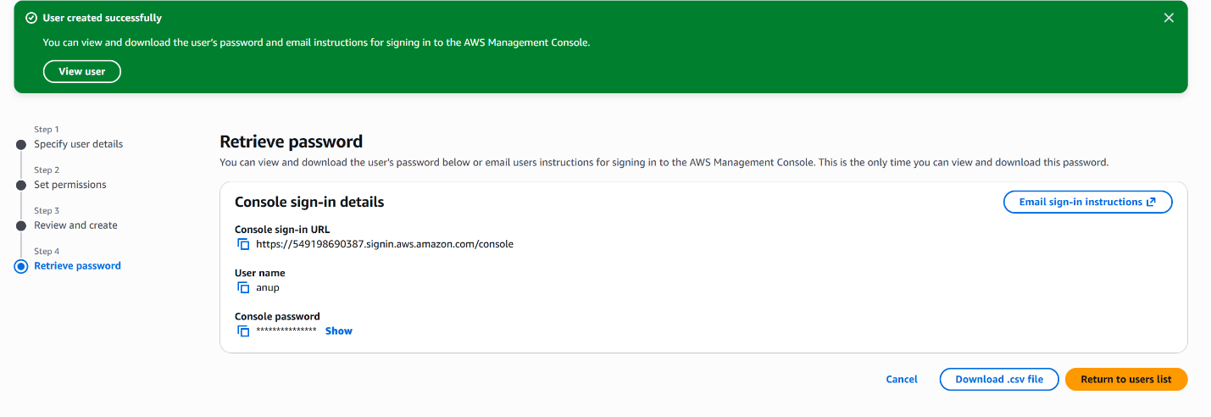

Part 1 B : Creating the Second User
Step 1 : Go to the Dashboard and Create User
Navigate to IAM → Users → Create user and fill in the following:
• User name: IamUserLearning2
• Console access: Enabled
• Console password: Custom password1
Step 2 : Setting Permissions
Same as User 1 — select Attach policies directly, search for s3, and check AmazonS3FullAccess.
• Select: Attach policies directly
• Search: s3 → Select: AmazonS3FullAccess
• Click Next

Step 3 — Review and Create User 2
Verify the summary on the Review and Click Create user to finalize.
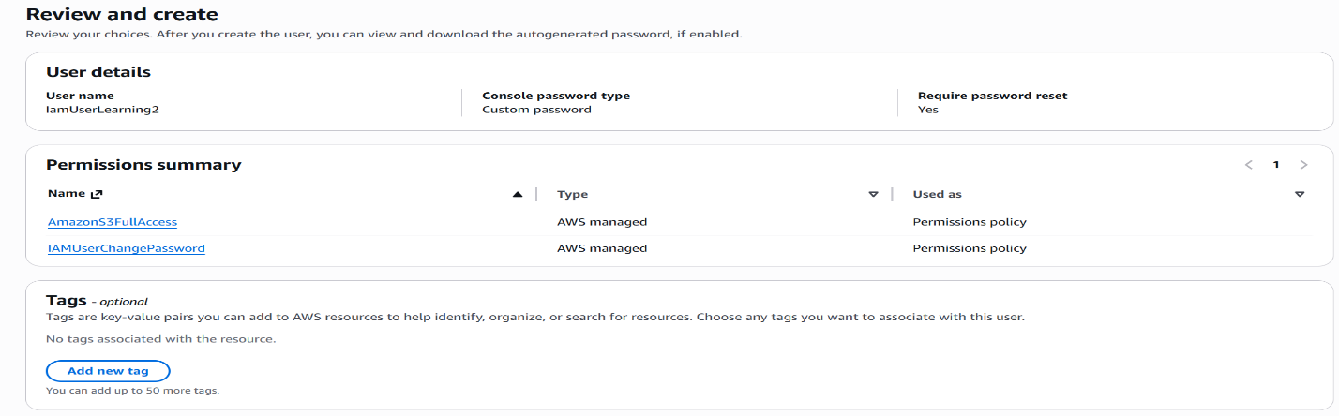

Step 4 — Retrieve Password and Confirm Creation
After clicking Create user, you will see a success banner: "User created successfully". The console then shows the sign-in credentials.
Save the details— the password will not be shown again:
• Console sign-in URL
• User name
• Console password

Part 2 : Creating an IAM User Group

Step 1 — Go to “User Groups”
In the IAM console, click User groups in the left sidebar → Click Create group.
Fill in the group details and add users:
• User group name: s3-user-group
• Add users to group: Select both anup and IamUserLearning2 (both should appear in the list)
• Attach permissions policies: Search and select the desired policy (e.g., AmazonS3FullAccess)
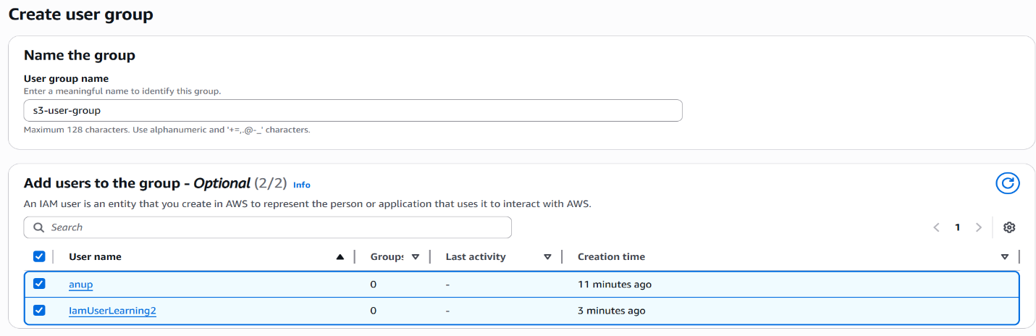

Step 2 — Confirm the group’s selection
After clicking Create group, a success banner confirms: "s3-user-group user group created."

The User groups list will now show:
• Group name: s3-user-group
• Users: 2
• Permissions: Not defined (if no policy was attached during creation — you can add one after)

